Create and push custom image to docker hub, pull custom image and create containers.

- Install docker and start docker
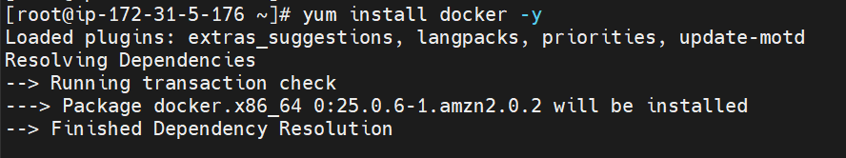
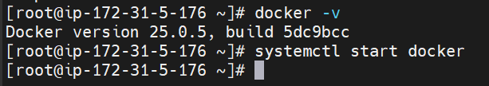

- Pull images and run containers
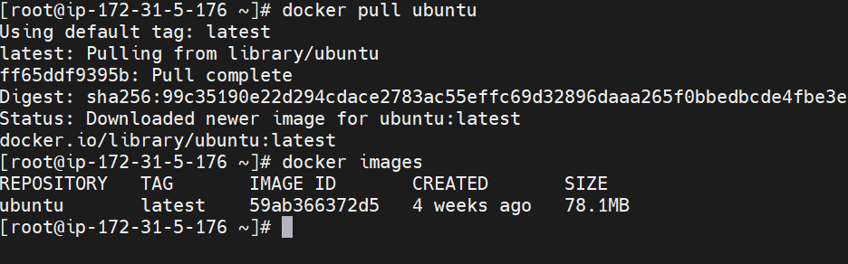
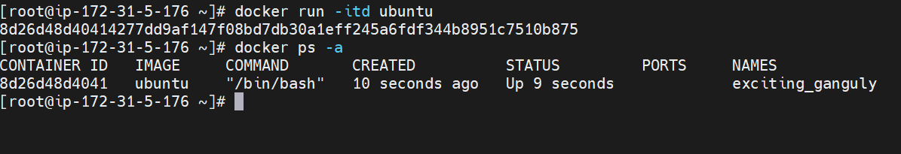

- Login into container and do some changes like install git and create index.html
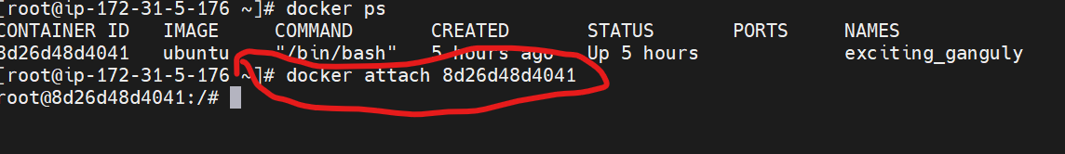
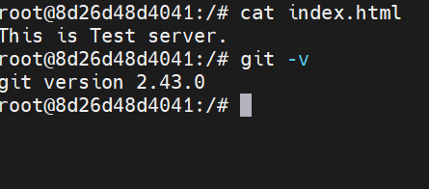

- Create image from containers but image name mast be username of docker hub/image-name: tag
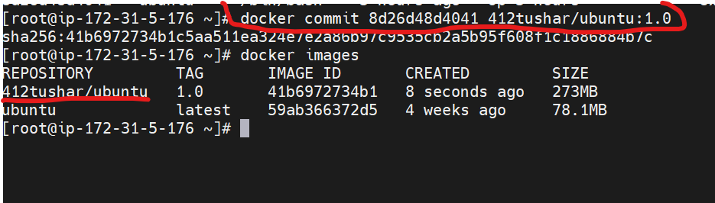

- Login to Docker hub (first reset password of docker hub then login username and password)

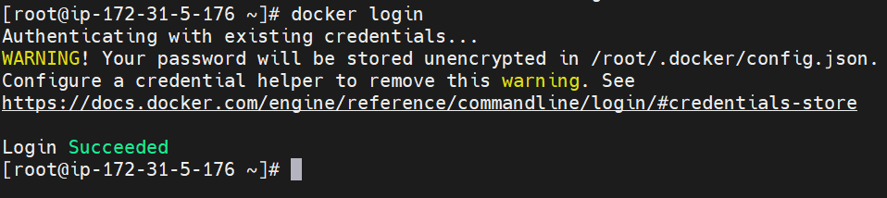

- Then image push on docker hub
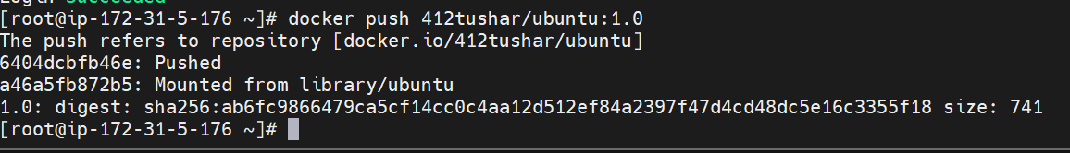
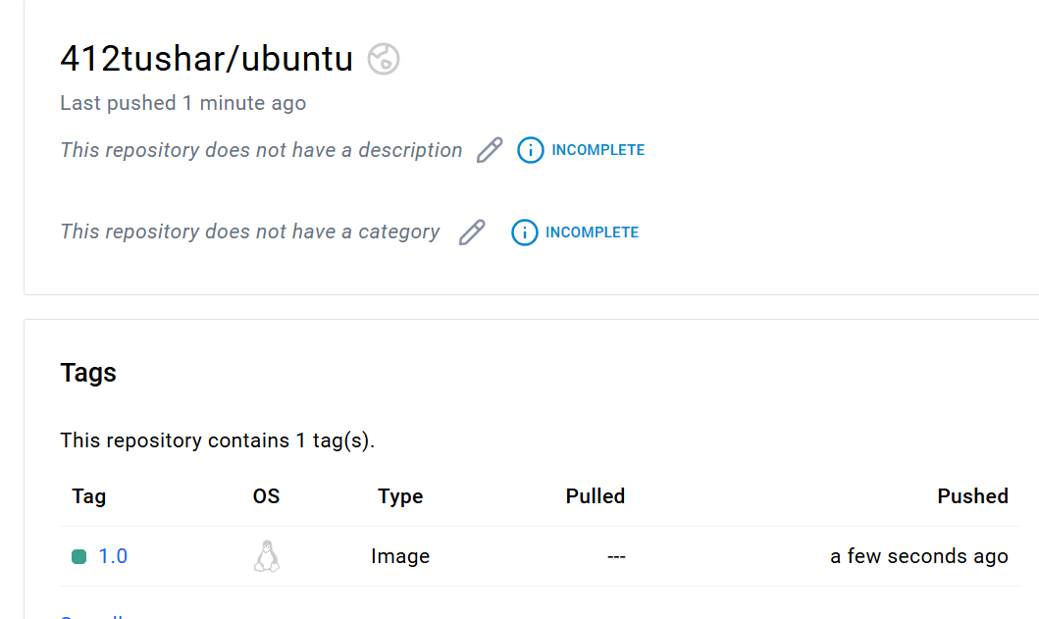

- Then clear all containers and image

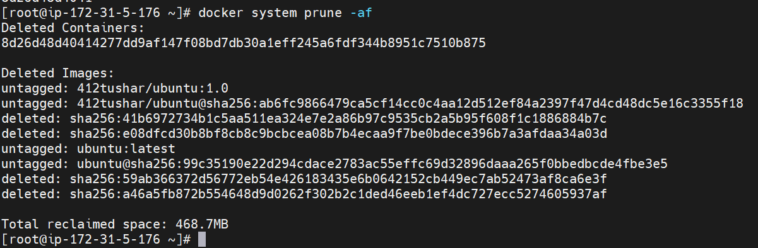

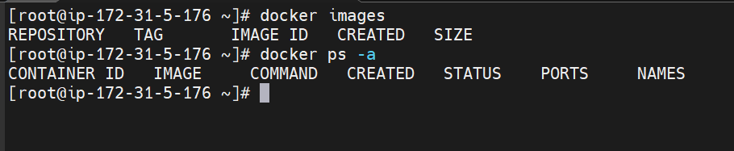

- Then pull custom image from docker hub and create container
